Analyzing Code Smell Removal Sequences for Enhanced Software Maintainability
Yukti Mehta
National Institute of Technology
Jalandhar, India
E-mail: yukti.mehta19@gmail.com

Ashish Sureka
Ashoka University
Haryana, India
E-mail: ashish.sureka@ieee.org

Paramvir Singh
National Institute of Technology
Jalandhar, India
E-mail: singhpv@nitj.ac.in

- metric values for project spinfo and refactored versions
Java Project | NOC | LOC | MI | RLC | MCI | CC
Spinfo | 12 | 1373 | 140.46 | 0.0048 | 6.74208 | 1.686
Spinfo-LM-GC-FE | 17 | 1398 | 141.78 | 0.060 | 8.5068 | 1.65
Spinfo-LM-FE-GC | 16 | 1406 | 142.29 | 0.060 | 8.5374 | 1.66
Spinfo-GC-LM-FE | 17 | 1410 | 142.29 | 0.0617 | 8.779293 | 1.66
Spinfo-GC-FE-LM | 17 | 1411 | 141.89 | 0.0616 | 8.740424 | 1.67
Spinfo-FE-LM-GC | 15 | 1399 | 142.25 | 0.0607 | 8.634575 | 1.65
Spinfo-FE-GC-LM | 16 | 1387 | 142.15 | 0.0612 | 8.69958 | 1.65
- metric values for project algorithms and refactored versions
Java Project | NOC | LOC | MI | RLC | MCI | CC
Algorithms | 17 | 620 | 80.77 | 0.095 | 7.673 | 1.68
Algorithms-LM-GC-FE | 21 | 868 | 103.16 | 0.070 | 7.221 | 1.829
Algorithms-LM-FE-GC | 21 | 870 | 103.16 | 0.070 | 7.221 | 1.831
Algorithms-GC-LM-FE | 20 | 877 | 103.26 | 0.067 | 6.918 | 1.821
Algorithms-GC-FE-LM | 20 | 878 | 103.26 | 0.067 | 6.918 | 1.823
Algorithms-FE-LM-GC | 21 | 865 | 103.31 | 0.069 | 7.128 | 1.823
Algorithms-FE-GC-LM | 21 | 860 | 103.87 | 0.07 | 7.270 | 1.823
- metric values for project frogger and refactored versions
Java Project | NOC | LOC | MI | RLC | MCI | CC
Frogger | 20 | 1283 | 114.74 | 0.123 | 14.113 | 1.859
Frogger-LM-GC-FE | 30 | 1613 | 114.75 | 0.1177 | 13.506 | 1.796
Frogger- LM-FE-GC | 30 | 1613 | 114.71 | 0.1171 | 13.432 | 1.815
Frogger- GC-LM-FE | 29 | 1600 | 114.74 | 0.11875 | 13.625 | 1.808
Frogger- GC-FE-LM | 29 | 1620 | 114.75 | 0.1126 | 12.920 | 1.835
Frogger- FE-LM-GC | 28 | 1555 | 114.61 | 0.1125 | 12.893 | 1.823
Frogger- FE-GC-LM | 27 | 1528 | 114.82 | 0.1191 | 13.675 | 1.854
- metric values for project javashootergame (jsg)and refactored versions
Java Project | NOC | LOC | MI | RLC | MCI | CC
JSG | 23 | 2378 | 52.14 | 0.058 | 3.024 | 3.178
JSG-LM-GC-FE | 24 | 2454 | 65.58 | 0.0599 | 3.928 | 3.017
JSG-LM-FE-GC | 27 | 2578 | 80.33 | 0.0655 | 5.261 | 2.893
JSG-GC-LM-FE | 24 | 2447 | 65.47 | 0.0592 | 3.875 | 3.04
JSG-GC-FE-LM | 24 | 2451 | 65.52 | 0.0595 | 3.898 | 3.028
JSG-FE-LM-GC | 24 | 2451 | 65.52 | 0.0595 | 3.898 | 3.028
JSG-FE-GC-LM | 24 | 2451 | 65.52 | 0.0595 | 3.898 | 3.028
- metric values for project javaboatgame (jbg)and refactored versions
Java Project | NOC | LOC | MI | RLC | MCI | CC
JBG | 30 | 3483 | 103.86 | 0.0315 | 1.395 | 1.395
JBG-LM-GC-FE | 43 | 3938 | 110.34 | 0.0286 | 1.303 | 1.303
JBG-LM-FE-GC | 44 | 3968 | 110.34 | 0.02872 | 1.298 | 1.298
JBG-GC-LM-FE | 42 | 3934 | 109.89 | 0.02872 | 1.303 | 1.303
JBG-GC-FE-LM | 43 | 3958 | 108.98 | 0.029 | 1.302 | 1.302
JBG-FE-LM-GC | 43 | 3942 | 108.67 | 0.028 | 1.302 | 1.302
JBG-FE-GC-LM | 44 | 3979 | 108.57 | 0.028 | 1.302 | 1.302
- metric values for project tigersland and refactored versions
Java Project | NOC | LOC | MI | RLC | MCI | CC
TigerIsland | 46 | 5564 | 98.93 | 0.0138 | 1.365 | 1.901
Tigersland-LM-GC-FE | 75 | 7023 | 110.61 | 0.0112 | 1.238 | 1.596
Tigersland-LM-FE-GC | 76 | 7026 | 110.78 | 0.0111 | 1.229 | 1.592
Tigersland-GC-LM-FE | 65 | 6784 | 110.5 | 0.0113 | 1.248 | 1.593
Tigersland-GC-FE-LM | 65 | 6811 | 111.75 | 0.0113 | 1.262 | 1.581
Tigersland-FE-LM-GC | 76 | 7018 | 110.71 | 0.01114 | 1.233 | 1.59
Tigersland-FE-LM-GC | 67 | 6880 | 109.6 | 0.01119 | 1.226 | 1.603
- metric values for project javagame and refactored versions
Java Project | NOC | LOC | MI | RLC | MCI | CC
JavaGame | 55 | 3673 | 114.74 | 0.043 | 4.933 | 1.859
JavaGame-LM-GC-FE | 69 | 4326 | 110.91 | 0.0423 | 4.691 | 1.743
JavaGame- LM-FE-GC | 69 | 4339 | 114.71 | 0.0435 | 4.989 | 1.762
JavaGame-GC-LM-FE | 67 | 4302 | 114.74 | 0.044 | 5.048 | 1.754
JavaGame-GC-FE-LM | 66 | 4236 | 114.82 | 0.0429 | 4.925 | 1.78
JavaGame-FE-LM-GC | 70 | 4312 | 114.61 | 0.040 | 4.584 | 1.769
JavaGame-FE-GC-LM | 66 | 4306 | 114.82 | 0.042 | 4.822 | 1.8
- metric values for project jpacman and refactored versions
Java Project | NOC | LOC | MI | RLC | MCI | CC
Jpacman | 55 | 2443 | 101.32 | 0.018 | 1.864 | 1.361
Jpacman- LM-GC-FE | 61 | 2697 | 127.8 | 0.0137 | 1.750 | 1.306
Jpacman- LM-FE-GC | 60 | 2678 | 127.79 | 0.0134 | 1.717 | 1.308
Jpacman-GC-LM-FE | 61 | 2701 | 127.8 | 0.0136 | 1.738 | 1.301
Jpacman-GC-FE-LM | 61 | 2698 | 127.8 | 0.0137 | 1.750 | 1.302
Jpacman-FE-LM-GC | 59 | 2668 | 127.79 | 0.0135 | 1.723 | 1.31
Jpacman-FE-GC-LM | 55 | 2557 | 127.8 | 0.0168 | 2.147 | 1.332
- metric values for project jadventureand refactored versions
Java Project | NOC | LOC | MI | RLC | MCI | CC
Jadventure | 60 | 4925 | 151.54 | 0.0190 | 1.955 | 1.955
Jadventure-LM-GC-FE | 68 | 5272 | 151.61 | 0.0180 | 1.877 | 1.877
Jadventure-LM-FE-GC | 64 | 5219 | 151.61 | 0.01762 | 1.869 | 1.869
Jadventure-GC-LM-FE | 64 | 5220 | 151.40 | 0.01762 | 1.866 | 1.866
Jadventure-GC-FE-LM | 64 | 5170 | 151.61 | 0.0177 | 1.877 | 1.877
Jadventure-FE-LM-GC | 64 | 5192 | 151.61 | 0.0182 | 1.871 | 1.871
Jadventure-FE-GC-LM | 62 | 5145 | 151.61 | 0.0184 | 1.883 | 1.883
- metric values for project javaanpr and refactored versions
Java Project | NOC | LOC | MI | RLC | MCI | CC
Javaanpr | 66 | 4782 | 150.49 | 0.0112 | 1.685 | 1.95
Javaanpr-LM-GC-FE | 75 | 5276 | 150.66 | 0.0102 | 1.536 | 1.835
Javaanpr-LM-FE-GC | 82 | 5490 | 150.66 | 0.0098 | 1.476 | 1.762
Javaanpr-GC-LM-FE | 77 | 5415 | 150.32 | 0.0107 | 1.608 | 1.78
Javaanpr-GC-FE-LM | 77 | 5439 | 150.32 | 0.0106 | 1.593 | 1.774
Javaanpr-FE-LM-GC | 73 | 5283 | 150.32 | 0.0109 | 1.638 | 1.824
Javaanpr-FE-GC-LM | 74 | 5369 | 150.32 | 0.0108 | 1.623 | 1.79

- metric values for project commonbeansutils and refactored versions
Java Project | NOC | LOC | MI | RLC | MCI | CC
CBS | 111 | 11734 | 148.85 | 0.0102 | 1.518 | 2.267
CBS-LM-GC-FE | 216 | 14035 | 150.62 | 0.0089 | 1.340 | 2.254
CBS-LM-FE-GC | 215 | 14110 | 151.23 | 0.0087 | 1.315 | 2.249
CBS-GC-LM-FE | 216 | 14267 | 150.69 | 0.0086 | 1.295 | 2.262
CBS GC-FE-LM | 216 | 14108 | 151.2 | 0.0088 | 1.330 | 2.25
CBS-FE-LM-GC | 217 | 14203 | 150.6 | 0.0088 | 1.325 | 2.252
CBS-FE-GC-LM | 217 | 14119 | 150.3 | 0.0088 | 1.322 | 2.251
- metric values for project pagseguro and refactored versions
Java Project | NOC | LOC | MI | RLC | MCI | CC
Pagseguro | 132 | 9075 | 41.52 | 0.0036 | 0.149 | 1.756
Pagseguro-LM-GC-FE | 142 | 9452 | 46.19 | 0.0032 | 0.147 | 1.706
Pagseguro-LM-FE-GC | 143 | 9464 | 56.95 | 0.0022 | 0.125 | 1.698
Pagseguro-GC-LM-FE | 141 | 9444 | 46.53 | 0.0030 | 0.139 | 1.706
Pagseguro-GC-FE-LM | 141 | 9405 | 50.71 | 0.0032 | 0.162 | 1.713
Pagseguro-FE-LM-GC | 142 | 9447 | 50.65 | 0.0033 | 0.167 | 1.708
Pagseguro-FE-GC-LM | 141 | 9403 | 50.75 | 0.0030 | 0.152 | 1.712
- metric values for project gnubridge (GBG) and refactored versions
Java Project | NOC | LOC | MI | RLC | MCI | CC
GBG | 160 | 11362 | 106.42 | 0.0068 | 0.723 | 1.486
GBG-LM-GC-FE | 179 | 12515 | 111.78 | 0.0040 | 0.447 | 1.477
GBG-LM-FE-GC | 177 | 12477 | 111.81 | 0.0044 | 0.491 | 1.477
GBG-GC-LM-FE | 179 | 11490 | 106.75 | 0.0045 | 0.480 | 1.48
GBG-GC-FE-LM | 178 | 12541 | 115.82 | 0.0036 | 0.416 | 1.48
GBG-FE-LM-GC | 179 | 12504 | 109.85 | 0.0040 | 0.439 | 1.477
GBG-FE-GC-LM | 179 | 12537 | 112.24 | 0.0043 | 0.482 | 1.479
- metric values for project dungeon and refactored versions
Java Project | NOC | LOC | MI | RLC | MCI | CC
Dungeon | 197 | 9988 | 154.64 | 0.0041 | 0.634 | 1.69
Dungeon-LM-GC-FE | 283 | 11567 | 157.11 | 0.0045 | 0.706 | 1.686
Dungeon-LM-FE-GC | 282 | 11786 | 157.11 | 0.0044 | 0.691 | 1.686
Dungeon-GC-LM-FE | 283 | 11259 | 157.11 | 0.0047 | 0.738 | 1.686
Dungeon-GC-FE-LM | 281 | 11871 | 160.16 | 0.0048 | 0.768 | 1.665
Dungeon-FE-LM-GC | 284 | 11487 | 155.22 | 0.0047 | 0.729 | 1.656
Dungeon-FE-GC-LM | 283 | 11562 | 168.90 | 0.0050 | 0.844 | 1.656
- metric values for project fernflower (FLR) and refactored versions
Java Project | NOC | LOC | MI | RLC | MCI | CC
FLR | 225 | 28989 | 78.46 | 0.0017 | 0.133 | 3.414
FLR-LM-GC-FE | 252 | 29217 | 155.48 | 0.0023 | 0.357 | 3.356
FLR-LM-FE-GC | 253 | 29209 | 155.48 | 0.0023 | 0.357 | 3.355
FLR-GC-LM-FE | 255 | 29164 | 150.78 | 0.0020 | 0.301 | 3.367
FLR-GC-FE-LM | 254 | 29160 | 155.23 | 0.0019 | 0.294 | 3.369
FLR-FE-LM-GC | 252 | 29205 | 154.91 | 0.0022 | 0.3408 | 3.356
FLR-FE-GC-LM | 252 | 29152 | 154.91 | 0.0022 | 0.3408 | 3.37

- metric values for project jsmpp and refactored versions
Java Project | NOC | LOC | MI | RLC | MCI | CC
Jsmpp | 307 | 18873 | 68.46 | 0.0047 | 0.321 | 1.581
Jsmpp- LM-GC-FE | 317 | 19754 | 110.57 | 0.0035 | 0.386 | 1.58
Jsmpp- LM-FE-GC | 319 | 19759 | 119.15 | 0.0035 | 0.417 | 1.569
Jsmpp-GC-LM-FE | 318 | 19555 | 118.7 | 0.0036 | 0.427 | 1.62
Jsmpp-GC-FE-LM | 319 | 19566 | 118.4 | 0.0036 | 0.426 | 1.59
Jsmpp-FE-LM-GC | 319 | 19455 | 95.64 | 0.0039 | 0.372 | 1.57
Jsmpp-FE-GC-LM | 318 | 19546 | 96.34 | 0.0038 | 0.366 | 1.57

G. Analysis of Clusters containing similar ratio of code smell insatnces
The subject systems analysed are divided into 4 types in which the projects present under each Type contain similar ratio of code smell instances. The ratio of code smell instances is calculated and then clustering is performed in which projects having similar ratio of code smell instances are gathered in one unique type. Thus, 4 types are created whose trends are analysed in Fig.5-8.
The Type 1 consists of 6 projects, Spinfo, Frogger, TigerIsland, JavaGame, Jpacman and JavaBoatGame. As per the trend analysed in Fig.5, it can be observed that 50% of Type 1 projects have maximum MI if FE-GC-LM code smell removal sequence is followed. To obtain minimum RLC for the projects having similar ratio as of Type 1 project applications, FE-LM-GC should be preferred as 83.33% of Type 1 projects have minimum value of RLC. For the metric MCI, 50% projects have maximum value by following the sequence GC-LM-FE.
To ensure minimum CC, LM-GC-FE should be followed to eliminate the code smell instances as 50% of Type 1 projects have the least value of CC. The final refactored versions generated after the code smell removal have maximum NOCl if code smells are eliminated in the order LM-GC-FE or LM-FE-GC while LM-FE-GC sequence produces the refactored code having maximum LOC.

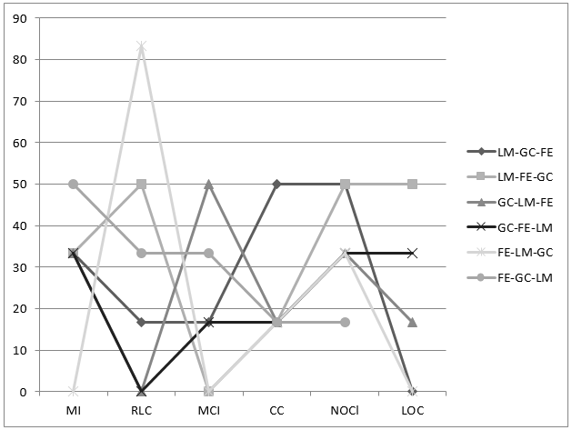
Fig 5. Trend Analysis of Applications under Type 1

Fig.6 describes the trend analysis of the applications under Type 2. Type 2 applications include Algorithms, CommonBeansUtils (CBS) and Dungeon. These applications have similar ratio of code smell instances. From the analysis it is found that 33.33% Type 2 projects have maximum MI if FE-GC-LM sequence is followed while to achieve minimum value of RLC, GC-LM-FE sequence can be preferred. To have maximum value of MCI, FE-GC-LM sequence produces best results. For least value of CC, LM-FE-GC, GC-LM-FE, FE-LM-GC or FE-GC-LM can be chosen. The FRV contains maximum number of classes if FE-LM-GC sequence is followed while the FRV can have maximum value of LOC if GC-FE-LM sequence is followed.
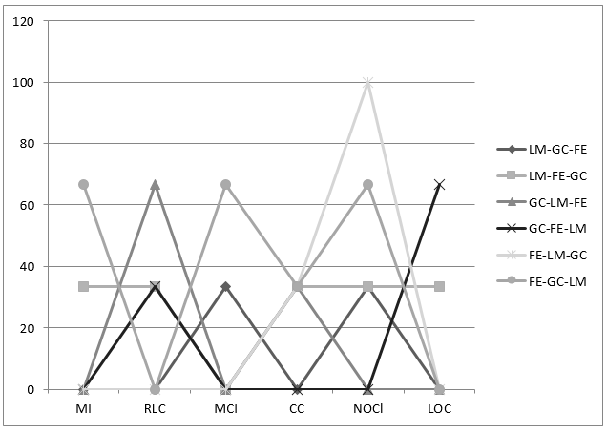
Fig 6. Trend Analysis of Applications under Type 2

The Type 3 applications include Jsmpp, Pagseguro and GnuBridge. The trend analysis is depicted by Fig.7. From the analysis, it is found that to achieve maximum value of MI, minimum value of RLC and minimum value of CC the sequence LM-FE-GC should be followed as 66.66% of projects have highest MI and least RLC and 100% projects have least value of CC for the above mentioned sequence. For maximum value of MCI, LM-GC-FE, GC-LM-FE or FE-LM-GC can be followed as 33.33% of projects have maximum MCI by following any of these sequences. By choosing the sequence LM-FE-GC or FE-LM-GC 66.66% projects have maximum classes in their FRV and 66.66% projects have maximum LOC by following sequence LM-FE-GC.
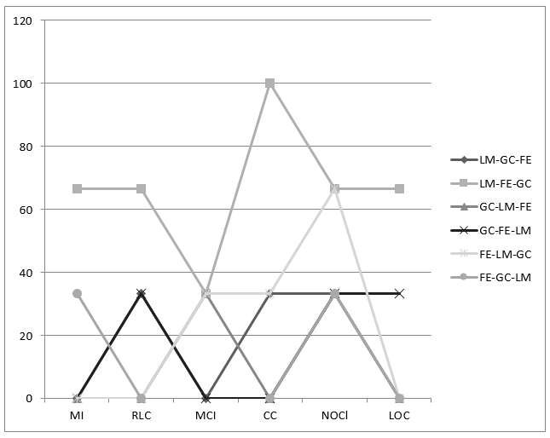
Fig 7. Trend Analysis of Applications under Type 3

Fig.8 gives the trend analysis for the applications belonging to Type 4. The Type 4 applications include Jadventure and Javaanpr. To achieve maximum value of MI and minimum value of RLC, the sequence LM-FE-GC should be followed as it gives 100% results. To achieve maximum value of MCI, FE-LM-GC or FE-GC-LM can be followed. 50% projects give minimum value of CC if the sequence LM-FE-GC or GC-LM-FE are followed. The 50% FRVs have maximum NOCl and maximum LOC by following the sequence LM-GC-FE or LM-FE-GC.
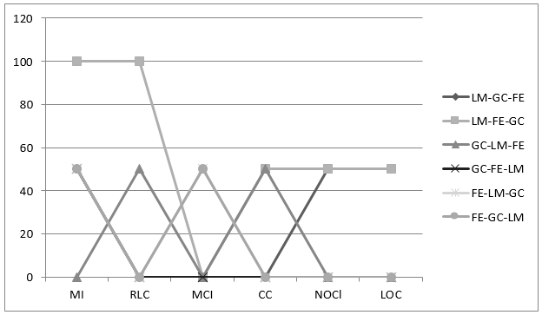
Fig 8. Trend Analysis of Applications under Type 4

